**Ulatra Festival**

Something I’ve realized about living in this amazing country is that there is always something fun to do, and that includes music festivals! Every weekend there seems to be some big event or party to check out, and new festivals are popping up all the time!

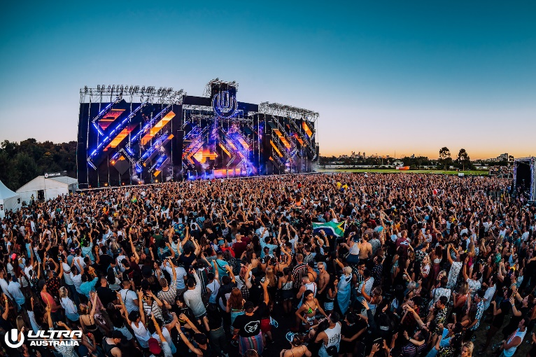

**When:**March 22-24, 2024

**Where in Sydney:** Parramatta Park

**Where in Melbourne:**Sidney Myer Music Bowl

“The iconic Ultra Music Festival remains the biggest and most successful music festival brand in the world. Together with the global team, we strive to deliver a unique, first-class music festival experience with stand-out production at premier venues. We are excited to bring ULTRA Australia back. The festival will once again feature both the mammoth Main Stage, and the hub of underground sounds with the Resistance Stage.  Following the success of this year’s events, the 2024 installments are expected to welcome 50,000 attendees across both the Sydney and Melbourne festivals.

From the jaw-dropping technological marvels that are the various, custom-designed stages, to the unbeatable festival atmosphere, to the beautiful backdrop of the inspiring and conveniently-located venues chosen to host the festival, ULTRA Australia takes pride in creating an all-encompassing entertainment experience for fans. These factors and others combine to allow the world’s top musical artists a canvas to create some of the best performances in the history of live music.”